Database Design

Here is an example of how you should complete questions 1 and 2
table name | column names
Patient | patientID, name
Disease | diseaseID, diseaseDescription
Patient_disease | patientID, diseaseID

Given the above tables and columns identify the information below in the empty slots

table name | primary key | foreign key(s) | table(s) referenced
patient | patientID
Disease | diseaseID
Patient_disease | patientID, diseaseID | patientID  diseaseID | Patient  Disease

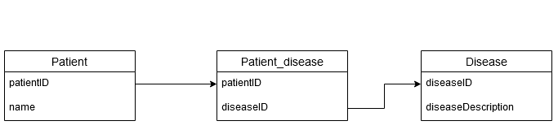

1)

Here are 5 tables with their respective columns

table name | column names
customer | customerID, name
flight | flightID, departureTime,arrivalTime,pilotID,planeID
pilot | pilotID, name
reservation | reservationID, customerID,flightID
plane | planeID, planeType, planeName

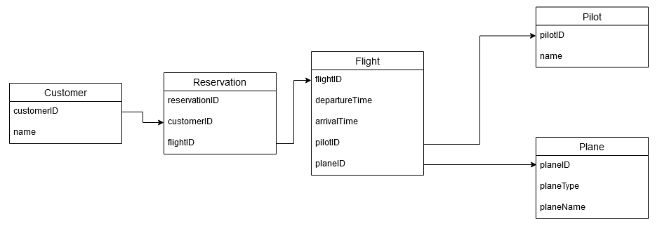

Given the above tables and columns identify the information below in the empty slots

table name | primary key | foreign key(s) | table(s) referenced
customer | customerID
flight | flightID | pilotID, planeID | Pilot, Plane
pilot | pilotID
reservation | reservationID | customerID, flightID | Customer, Flight
plane | planeID

2)

Come up with your own unique example just like the above exercise.
This must be your own unique example different from other people in the class. It must also be different from the normalization group assignment..

Use the same format as above. Your example must contain at least four tables.

table name | column names
Customer | customer_ID, name, customer_Address
Orders | order_Num, customer_ID, shipment_ID
Shipment | shipment_ID, departure_Time, arrival_Time, driver_ID, truck_ID
Driver | driver_ID, driver_Name, driver_Permit_Num
Truck | license_Plate_Num, truck_Brand, truck_Model

table name | primary key | foreign key(s) | table(s) referenced
Customer | customer_ID
Orders | order_Num | customer_ID, shipment_ID | Customer, Shipment
Shipment | shipment_ID | driver_ID, truck_ID | Driver, Truck
Driver | driver_ID
Truck | truck_ID

